The purpose of this project was to create a fully functional Real Estate Agency Portal using PHP and MySQL. The platform allows agents, buyers, and renters to interact with property listings in a realistic real estate environment. Agents can add and manage property listings, while buyers and renters can browse properties, save favorites, and submit inquiries. The project was developed using PHP for the website functionality and MySQL for the database management system. The website also uses sessions, secure logins, role-based access control, SQL relationships, and database views. The design and sample data were inspired by the game BioShock and the underwater city of Rapture. The main purpose of this project is to simulate a real estate agency platform where multiple types of users can interact with property listings and services. The system allows users to register accounts, log in securely, browse available properties, save favorite properties, and submit inquiries about listings. Agents are responsible for adding and managing property listings, while buyers and renters can explore available residences and contact agents through the inquiry system. The database for this project is named real_estate_portal. The database was created using phpmyadmin and contains multiple related tables that work together to support the functionality of the website.

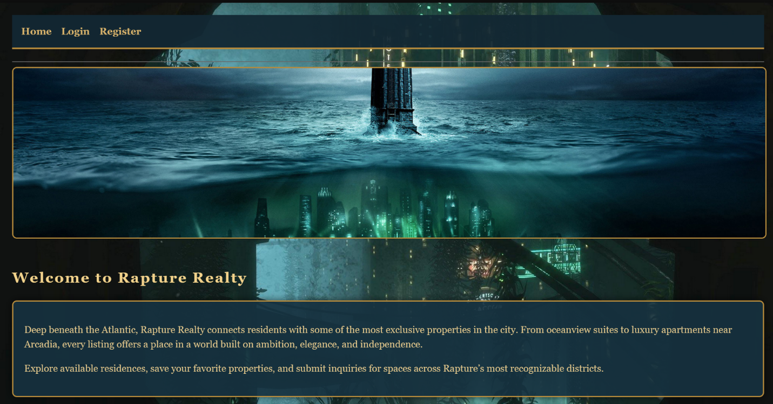

The Users table stores all users of the platform, including agents, buyers, and renters. Each user has a unique user ID, username, contact information, password hash, and user role. Passwords are stored securely using hashed passwords instead of plain text passwords for better security. 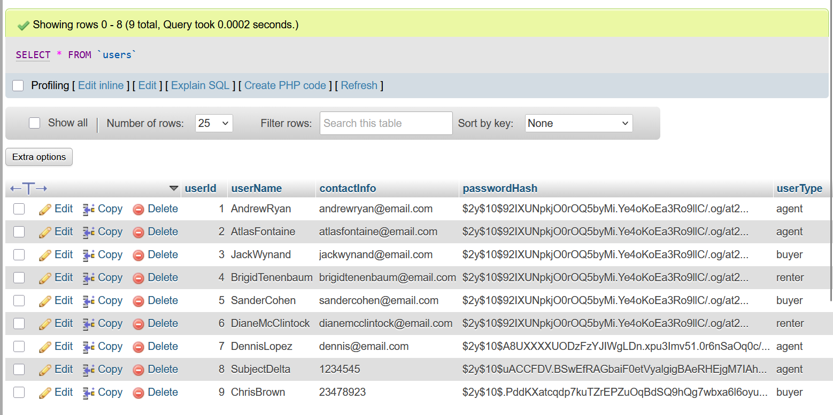
The Properties table stores all property listings added by agents. Each property contains a title, property type, address, city, price, status, and the agent ID of the user who created the listing. The agent ID is connected to the Users table through a foreign key relationship.
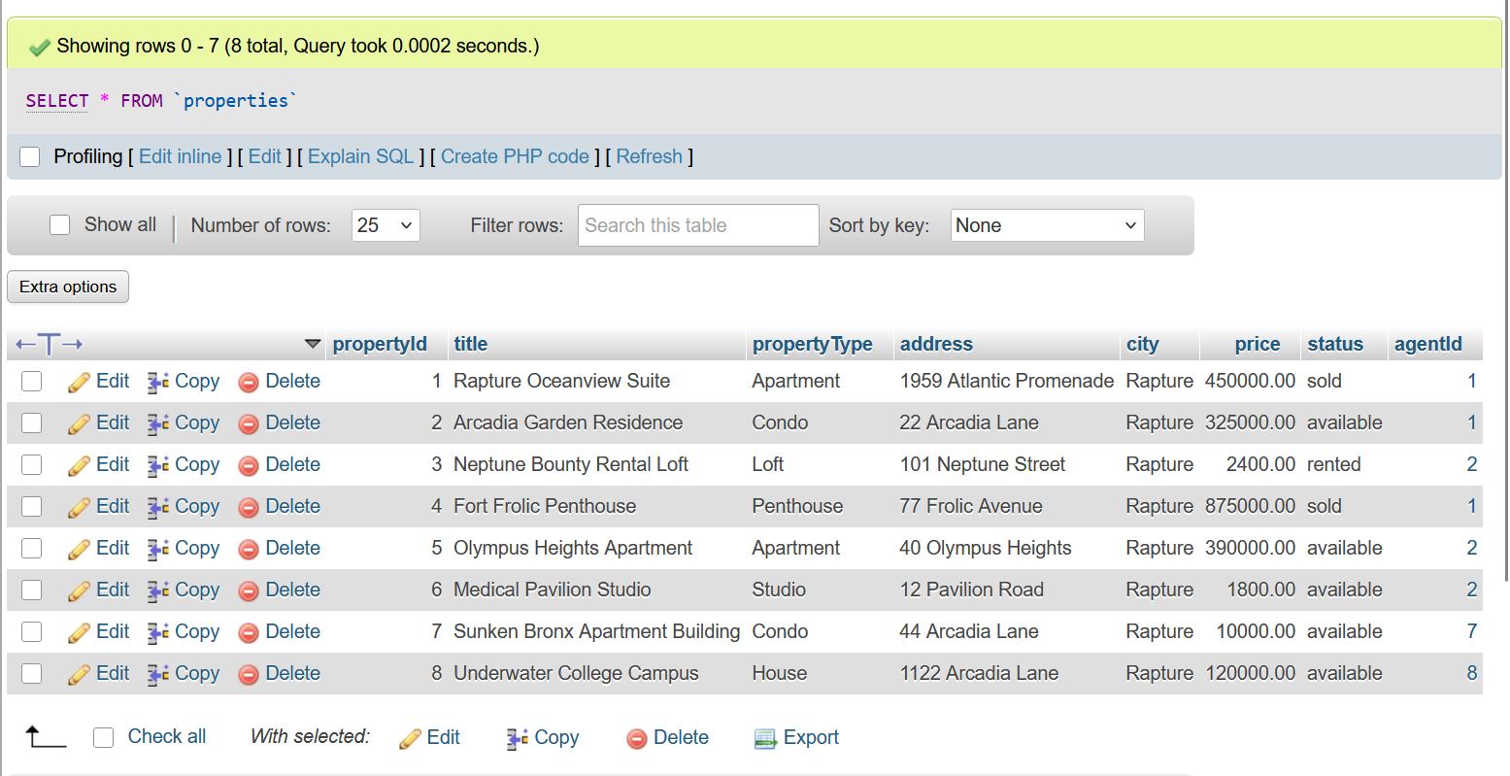
The Inquiries table stores messages submitted by buyers and renters regarding properties they are interested in. Each inquiry is connected to both a user and a property using foreign keys, allowing the system to track which user submitted the inquiry and which property the inquiry belongs to.
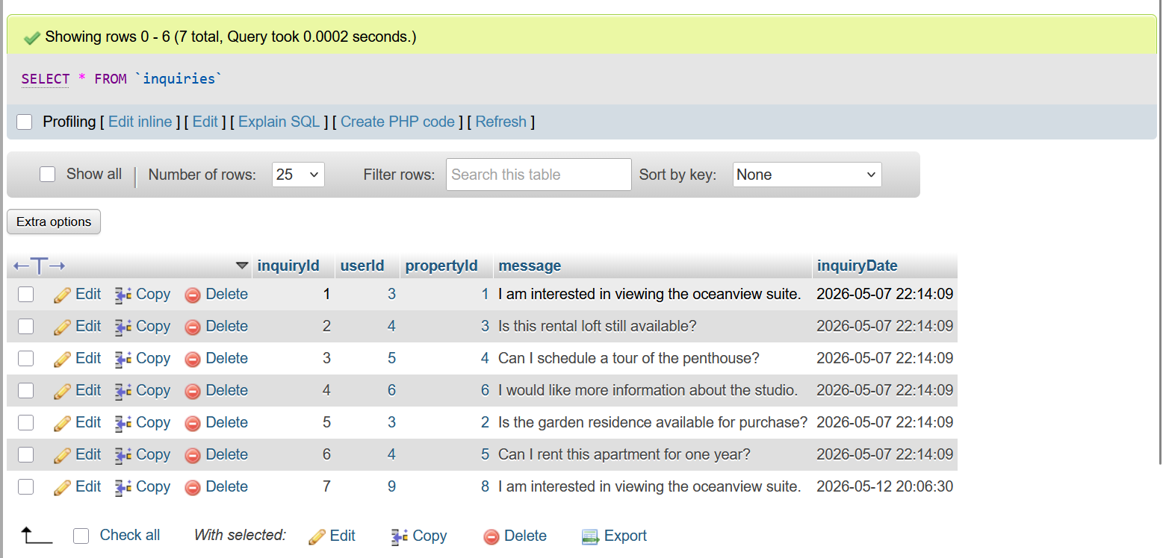
The Transactions table stores completed sales and rental transactions. Each transaction records the property involved, the user involved, the transaction type, the date of the transaction, and the transaction amount. This allows the system to track completed purchases and rentals.
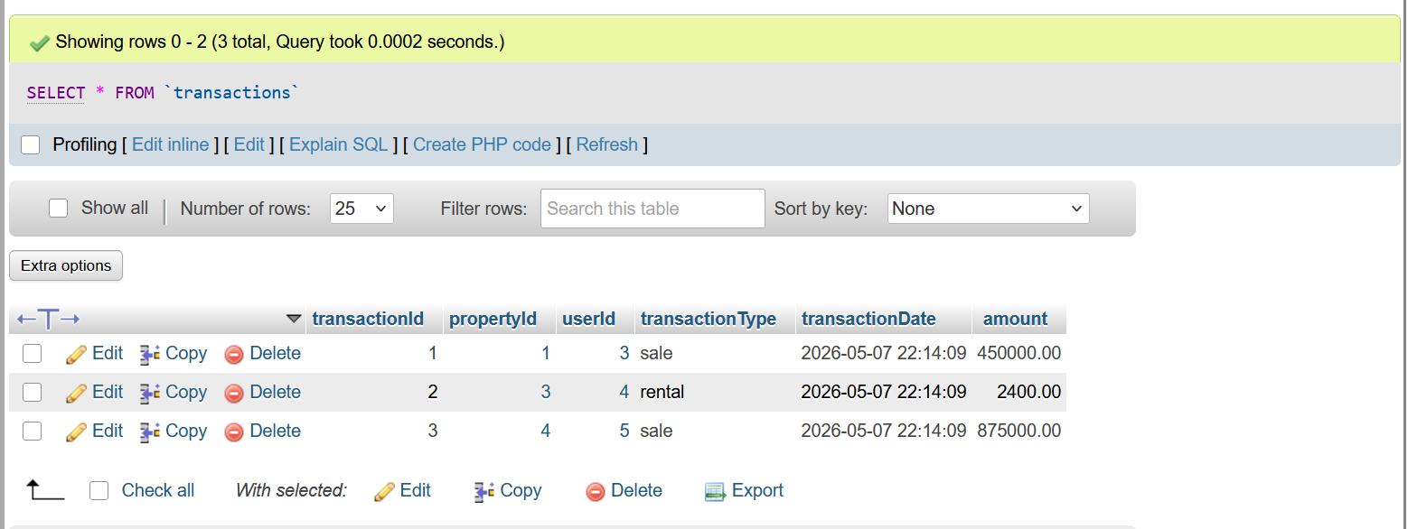

The Favorites table stores saved properties for buyers and renters. This feature allows users to save listings they are interested in and access them later.
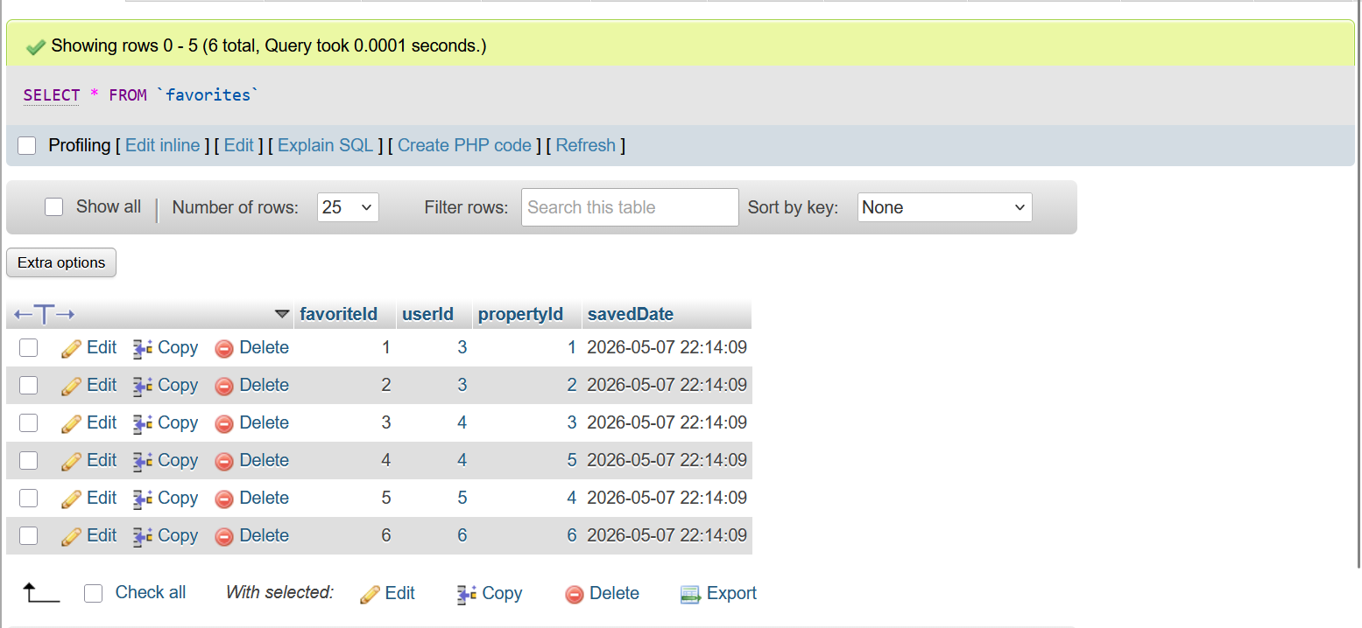
The website was developed using PHP pages connected to MySQL through PDO database connections. Important PHP pages include index.php, login.php, register.php, dashboard.php, properties.php, property_details.php, add_property.php, submit_inquiry.php, and logout.php. These pages work together to provide the functionality of the website. The project also uses a database class called RealEstateDatabase.php. This file contains reusable database methods such as addUser(), getUserByUsername(), addProperty(), getAllProperties(), getPropertyById(), and addInquiry(). Using a separate database class helped keep the project organized and reduced repeated code throughout the website. Prepared statements were used throughout the project to help prevent SQL injection attacks and improve security. The PHP pages use forms and POST requests to send user data to the database.
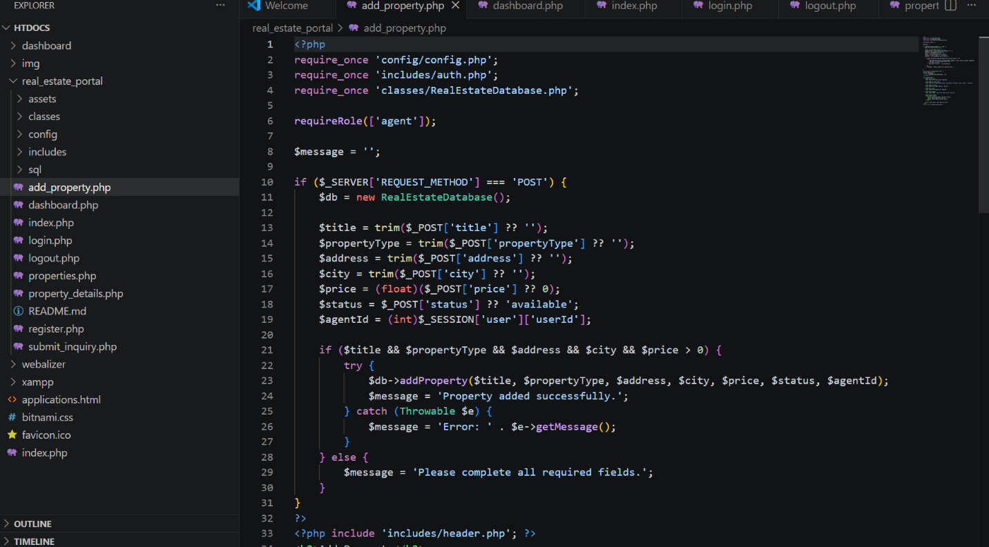
The login system was implemented using PHP sessions and secure password hashing. When a user registers on the website, the password is hashed using PHP’s password_hash() function before being stored in the database. When the user logs in, the entered password is verified using password_verify() to compare the plain text password with the hashed password stored in the Users table. If the login is successful, the user information is stored inside a PHP session using $_SESSION['user']. The session keeps the user logged in while navigating throughout the website. The logout page destroys the session and logs the user out of the system. This system improves security because passwords are not stored as plain text and users must authenticate before accessing restricted pages.
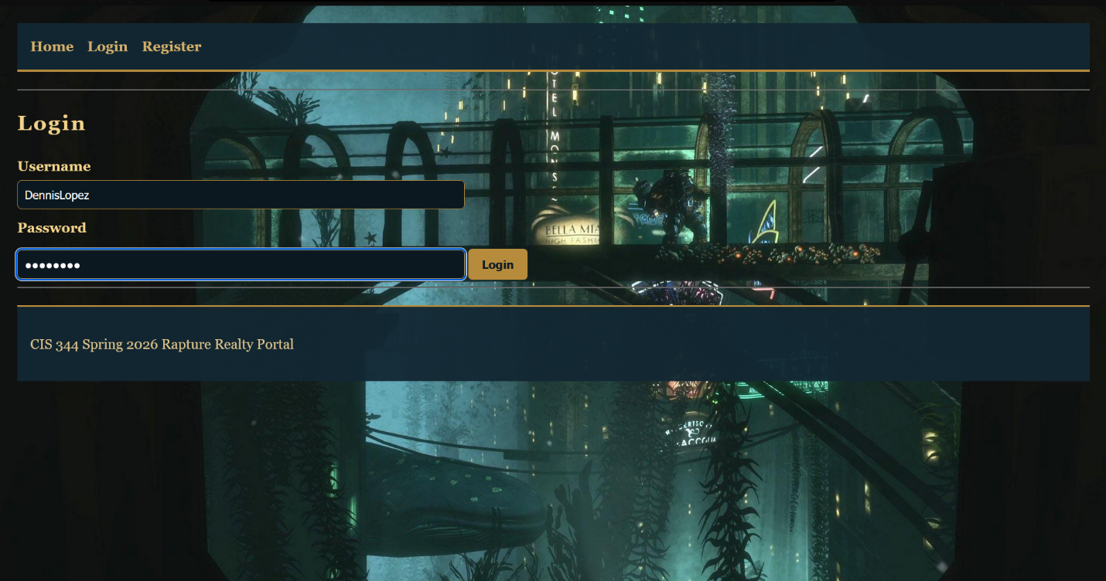
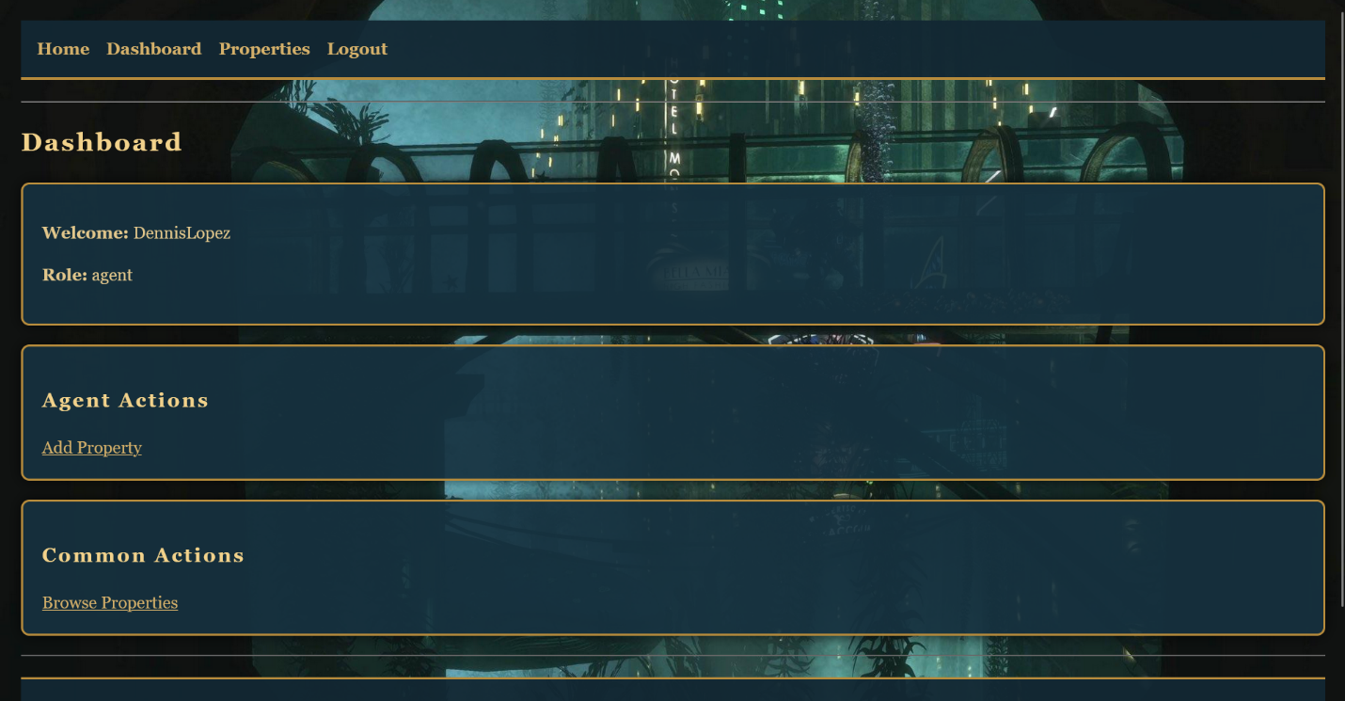
The project uses role-based access control to restrict features based on the user type. The platform supports three user roles: agent, buyer, and renter. Agents have permission to add and manage property listings, while buyers and renters can browse properties, save favorites, and submit inquiries. Role restrictions were implemented using the requireRole() function inside auth.php. This function checks the currently logged-in user’s role before allowing access to certain pages. For example, the Add Property page is restricted to agents only, preventing buyers and renters from accessing agent-only features. This role-based system helps organize the platform and makes the project function more like a real-world real estate application.
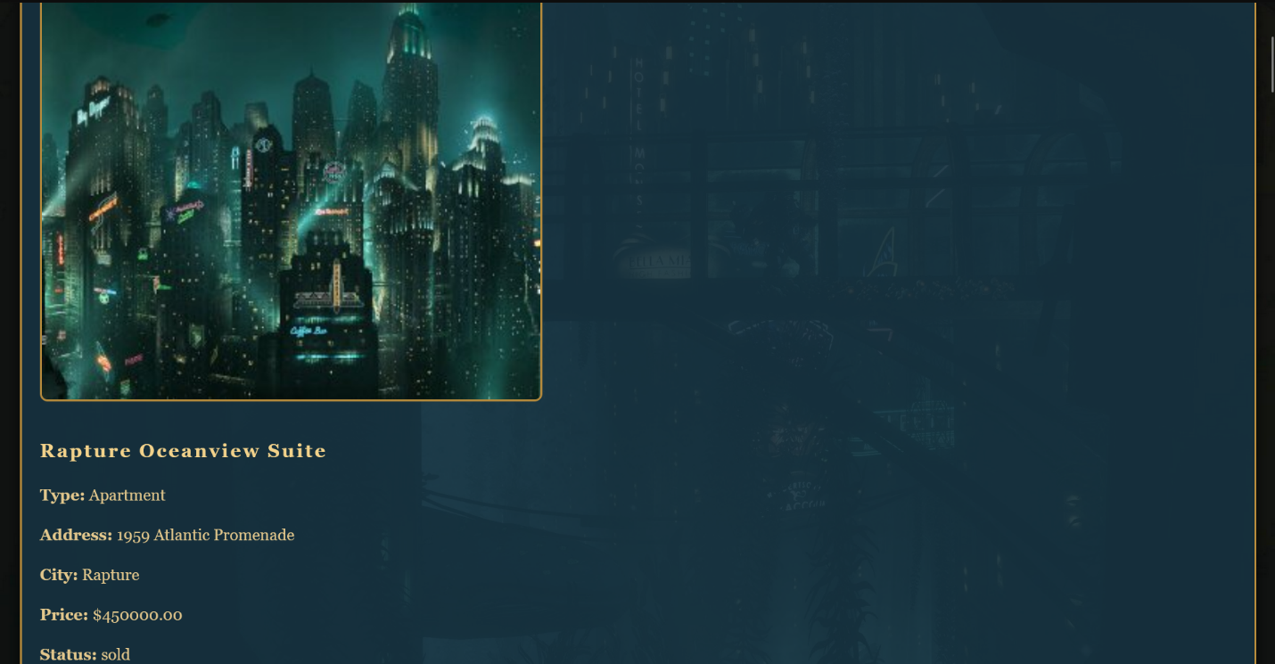
One of the biggest challenges during development was implementing the secure login system. Initially, the passwords did not work correctly because hashed passwords cannot be compared directly to plain text passwords. This issue was solved by using password_hash() during user registration and password_verify() during login. Another challenge was connecting all PHP pages to the database correctly. Some pages originally produced database connection or session errors. This problem was solved by organizing the project into reusable files such as config.php, auth.php, and RealEstateDatabase.php. Another challenge involved styling the website and making it visually unique. A BioShock-inspired design was created using CSS, dark colors, background images, and underwater styling to create the atmosphere of Rapture while still maintaining the functionality of a professional real estate portal.

